Digital Control for Lighting Report

Date: 11/15/2017

Ajay Rao (abrao2@ncsu.edu)

## Basic Controller (Asynchronous Sampling and Busy-Waiting for ADC)

|  |  |  |  |
| --- | --- | --- | --- |
| **Controller Type** | **Control Loop Frequency (fctl)** | **CPU Utilization by Controller** | **Maximum Absolute Value of Current Error** |
| **Bang-Bang** | 5.031 KHz | 5.11% | 522.18mA |
| **Proportional** | 5.031 kHz | 15.17 % | 26.92mA |
| **PID** | 5.031 KHz | 21.05% | 24.95mA |

**Bang Bang Controller:**

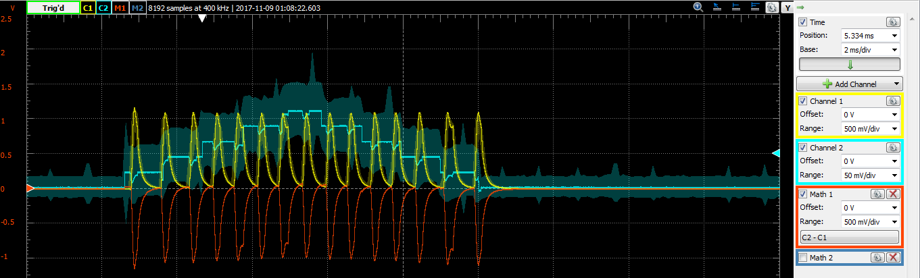

**PID: 0.04/0.159**

**BB: 0.0107/0.19867**

**P: 0.03017/0.19877**

**Proportional Controller:**

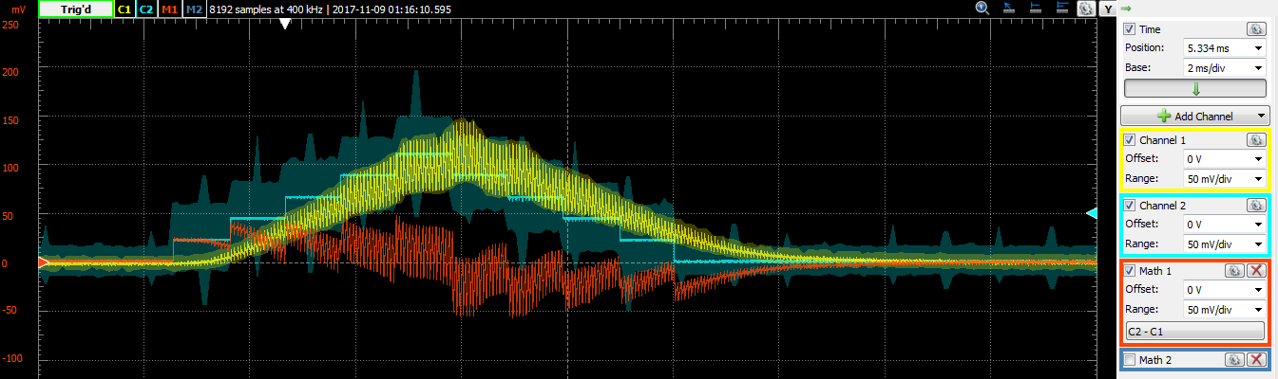

**PID Controller:**

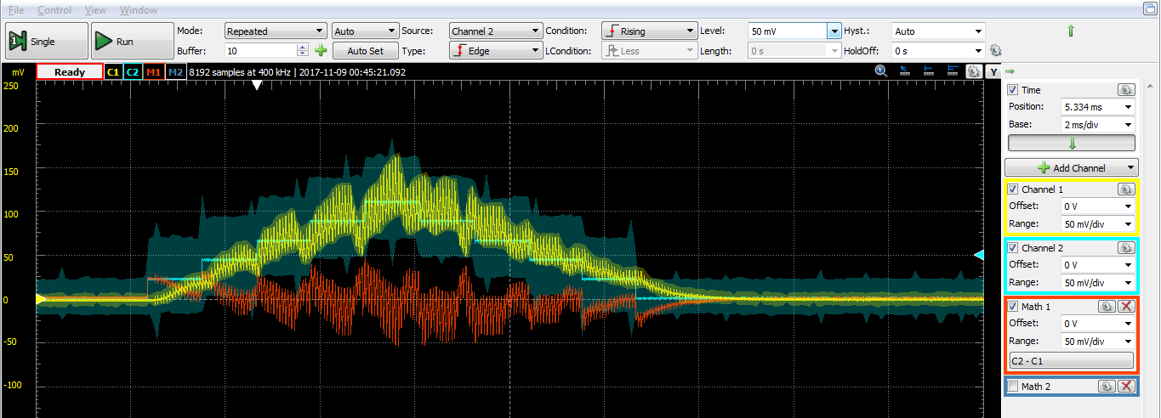

## Synchronous Sampling

|  |  |  |  |
| --- | --- | --- | --- |
| **Controller Type** | **Control Loop Frequency (fctl)** | **CPU Utilization by Controller** | **Maximum Absolute Value of Current Error** |
| **Bang-Bang** | 8 kHz | 8.2 % | 524 mA |
| **Proportional** | 8 kHz | 24.2 % | 25.32mA |
| **PID** | 8 kHz | 32.33 % | 19.98mA |

**BangBang Controller:**

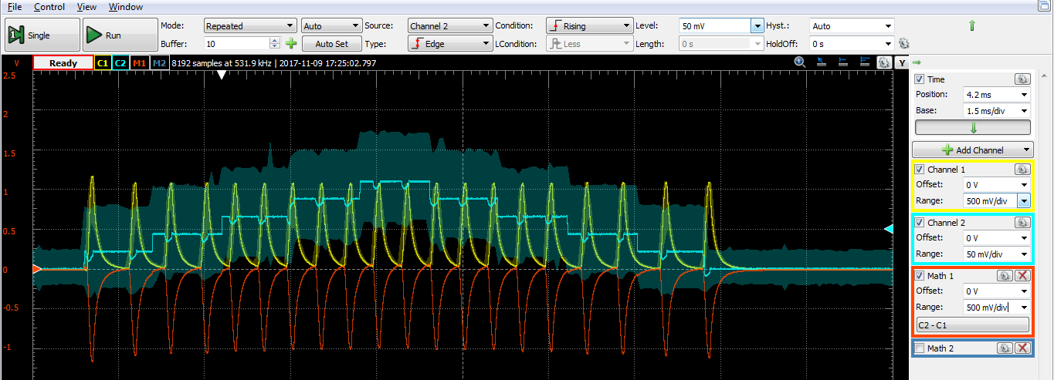

P: 30.25/125

PID: 40.42/125

B: 0.01025/0.125

**Proportional Controller:**

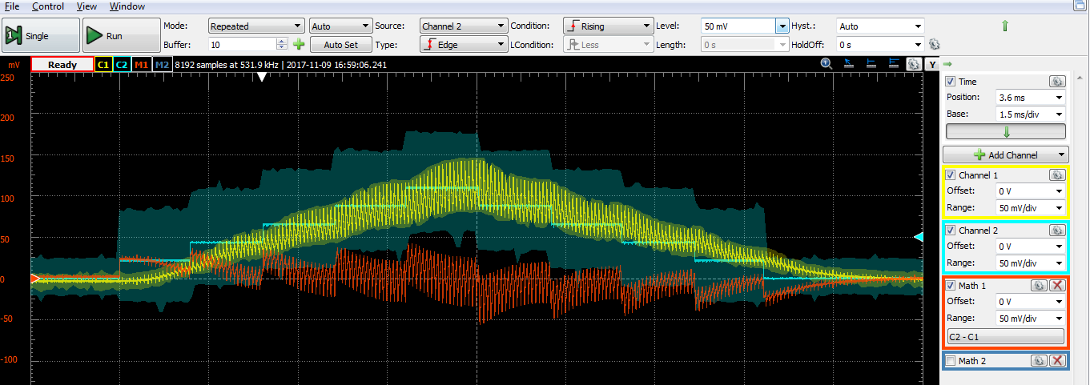

**PID Controller:**

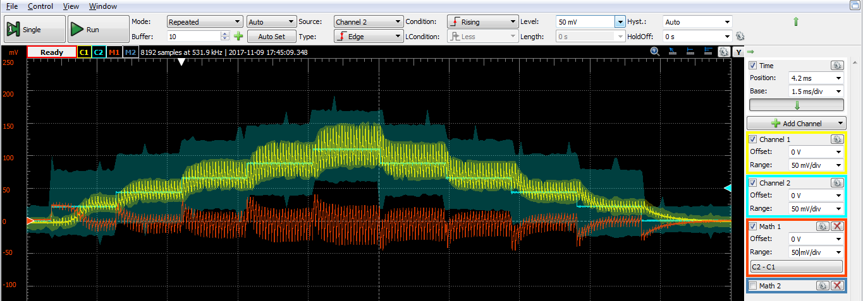

## Eliminating ADC Busy-Waiting

|  |  |  |  |
| --- | --- | --- | --- |
| **Controller Type** | **Control Loop Frequency (fctl)** | **CPU Utilization by Controller** | **Maximum Absolute Value of Current Error** |
| **Bang-Bang** | 8 kHz | 6.4 % | 523.86 mA |
| **Proportional** | 8 kHz | 22.7 % | 25.172 mA |
| **PID** | 8 kHz | 31.53 % | 19.81 mA |

**BangBang Controller:**

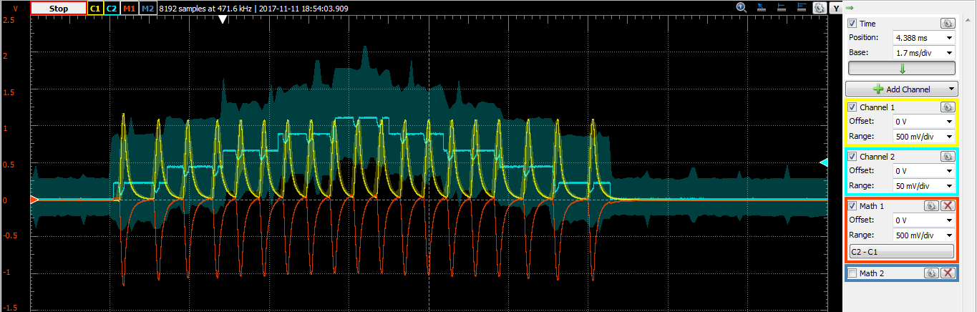

**PID 0.03942/0.125**

**B 0.008/0.125**

**P 0.0284/0.125**

**Proportional Controller:**

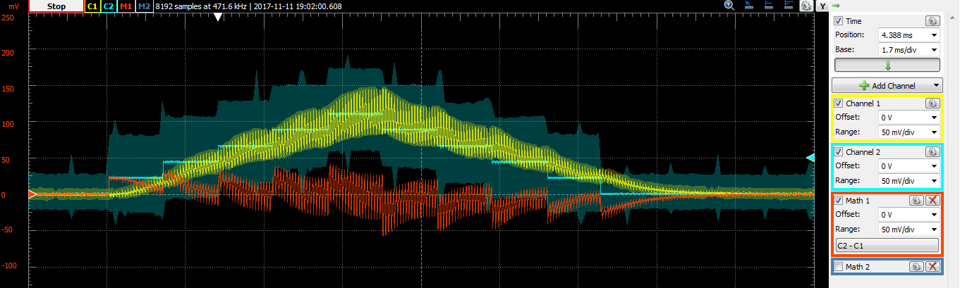

**PID Controller:**

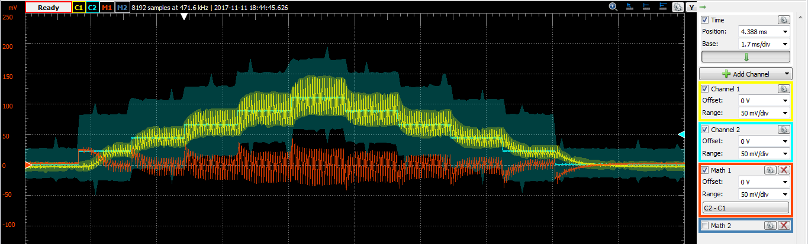

## ECE 561: Raising Control Loop Frequency

|  |  |  |  |
| --- | --- | --- | --- |
| **Controller Type** | **Control Loop Frequency (fctl)** | **CPU Utilization by Controller** | **Maximum Absolute Value of Current Error** |
| **Proportional** | 16 kHz | 45.68 % | 23.95 mA |
| **PID** | 16 kHz | 64.27% | 29.502 mA |

P 28.67/62.5

PID 40.17/62.5

**Proportional Controller:**

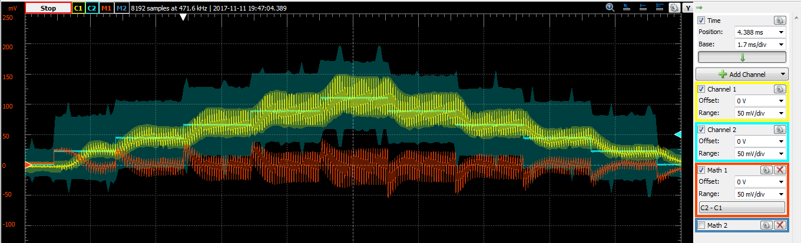

**PID Controller:**

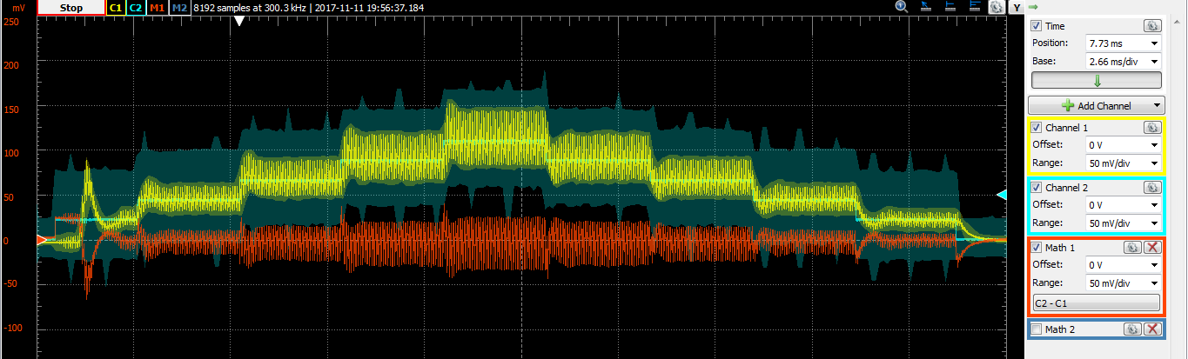

Maximum possible control loop frequency for each control approach (CPU utilization = 100%)

Proportional - 32 kHz

PID - 48 kHz

## ECE 561: ADC Interrupt Filtering

|  |  |  |  |
| --- | --- | --- | --- |
| **Controller Type** | **Control Loop Frequency (fctl)** | **Average CPU Utilization by Controller** | **Maximum Absolute Value of Current Error** |
| **Proportional** | 16 KHz | 37.84% | 24.522 mA |
| **PID** | 16 KHz | 53.08% | 27.833 mA |

**Proportional Controller:**

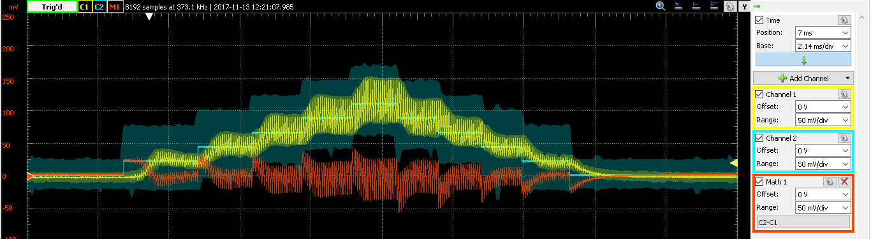

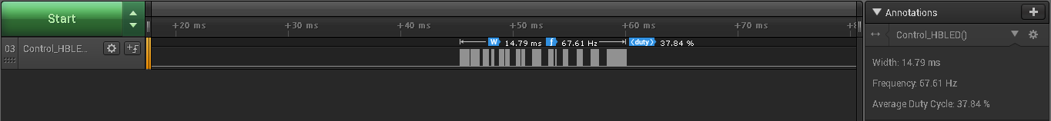

**PID Controller:**

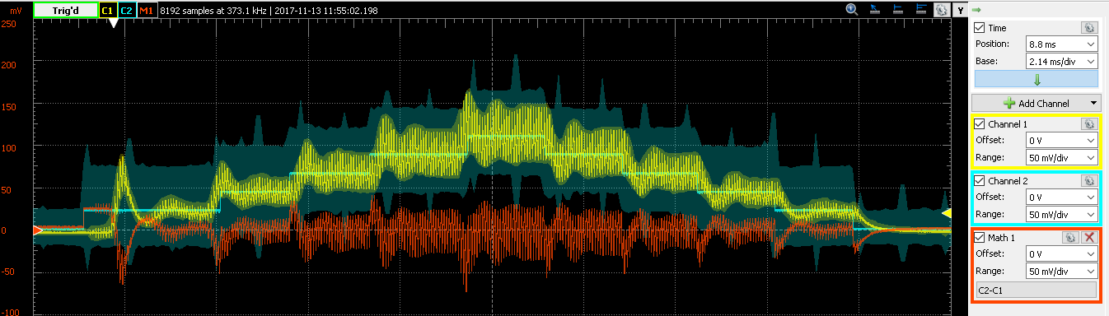

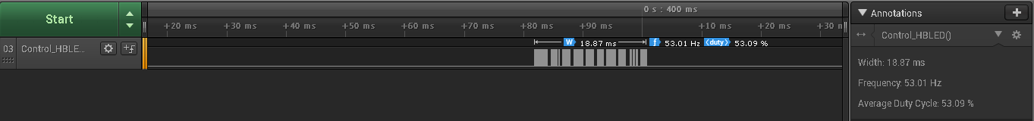

## Extra Credit: ADC Interrupt Filtering Sensitivity Analysis

**Allowed Current Error = 4mA**

|  |  |  |  |
| --- | --- | --- | --- |
| **Controller Type** | **Control Loop Frequency (fctl)** | **Average CPU Utilization by Controller** | **Maximum Absolute Value of Current Error** |
| **Proportional** | 16 KHz | 22.48% | 24.4101mA |
| **PID** | 16 KHz | 29.97% | 23.217mA |

**Proportional Controller:**

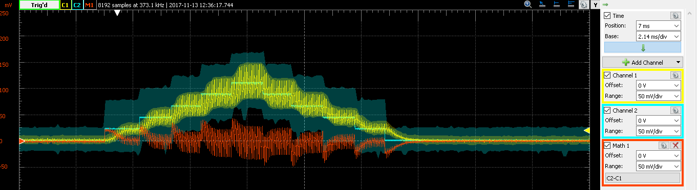



**PID Controller:**

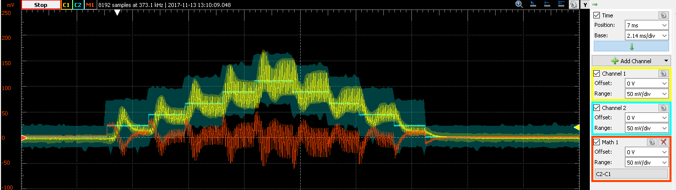

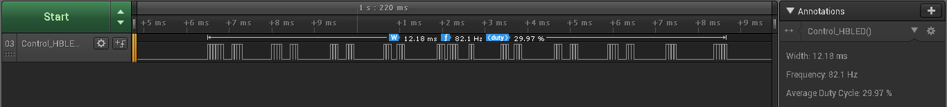

**Allowed error = 2mA**

|  |  |  |  |
| --- | --- | --- | --- |
| **Controller Type** | **Control Loop Frequency (fctl)** | **Average CPU Utilization by Controller** | **Maximum Absolute Value of Current Error** |
| **Proportional** | 16 KHz | 28.54% | 26.5474 mA |
| **PID** | 16 KHz | 43.68% | 28.819mA |

**Proportional Controller:**

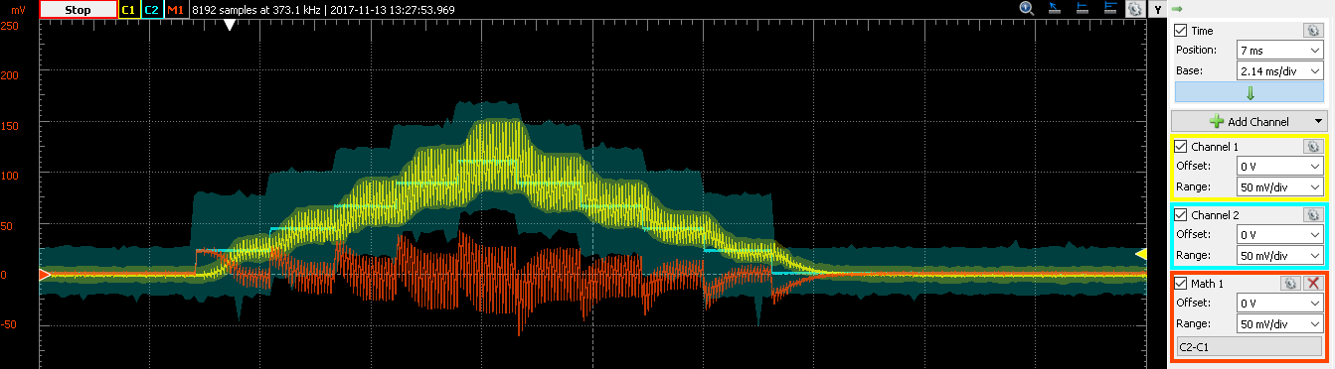

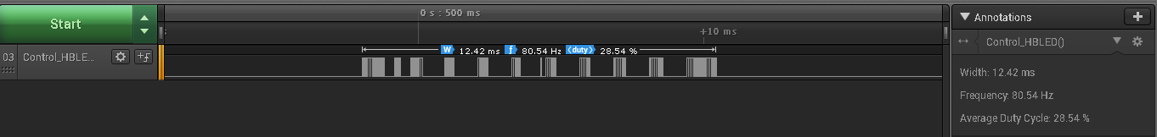

**PID Controller:**

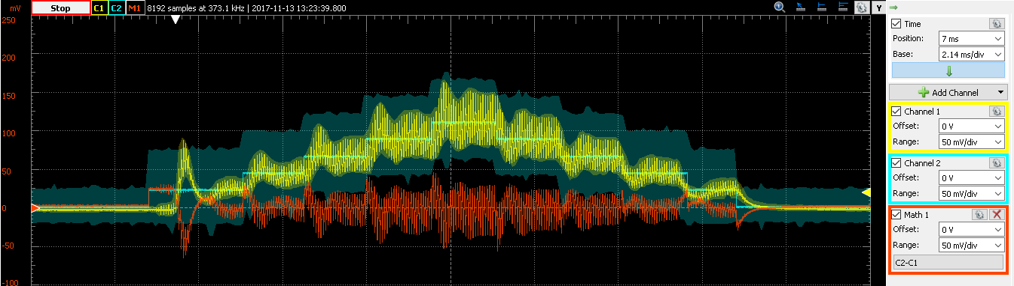



**Allowed Current = 0.5mA**

|  |  |  |  |
| --- | --- | --- | --- |
| **Controller Type** | **Control Loop Frequency (fctl)** | **Average CPU Utilization by Controller** | **Maximum Absolute Value of Current Error** |
| **Proportional** | 16 KHz | 42.998% | 20.96 mA |
| **PID** | 16 KHz | 54.32 % | 26.92 mA |

**Proportional Controller:**

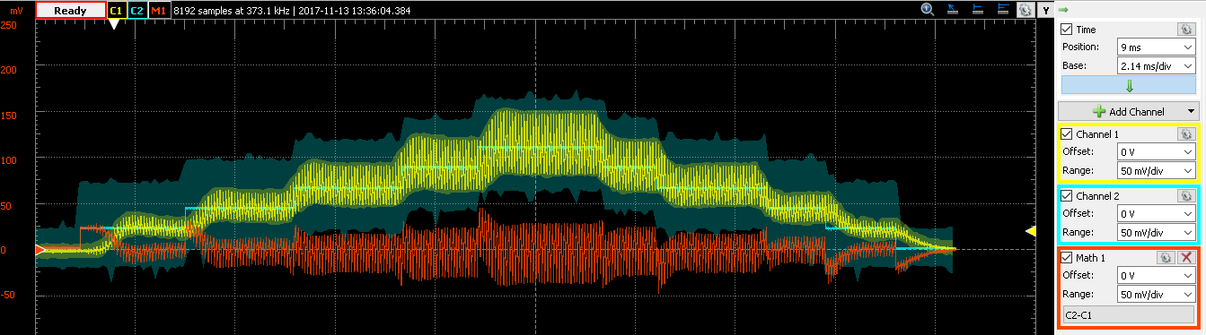

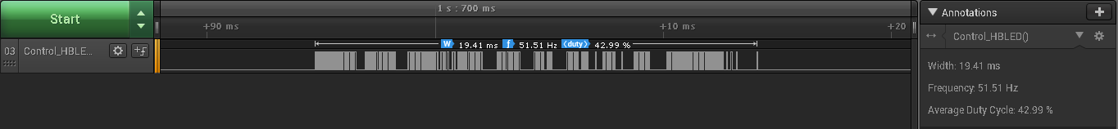

**PID Controller:**

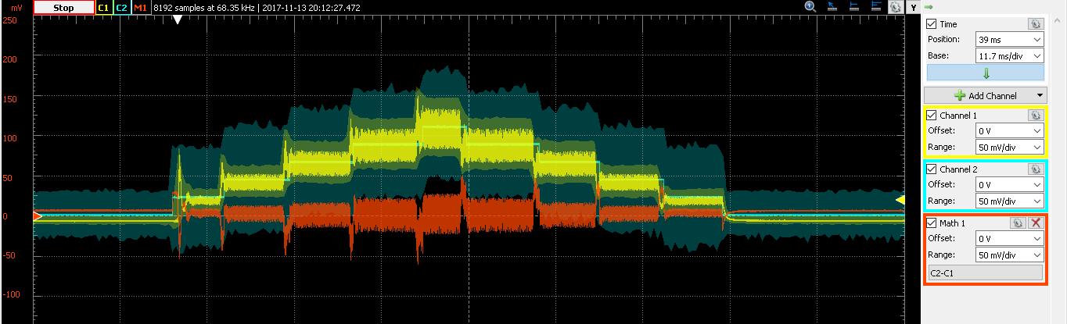



**Allowed Current = 0.1 mA**

|  |  |  |  |
| --- | --- | --- | --- |
| **Controller Type** | **Control Loop Frequency (fctl)** | **Average CPU Utilization by Controller** | **Maximum Absolute Value of Current Error** |
| **Proportional** | 16 KHz | 42.94 % | 21.96 mA |
| **PID** | 16 KHz | 60.49% | 26.38 mA |

**Proportional Controller:**

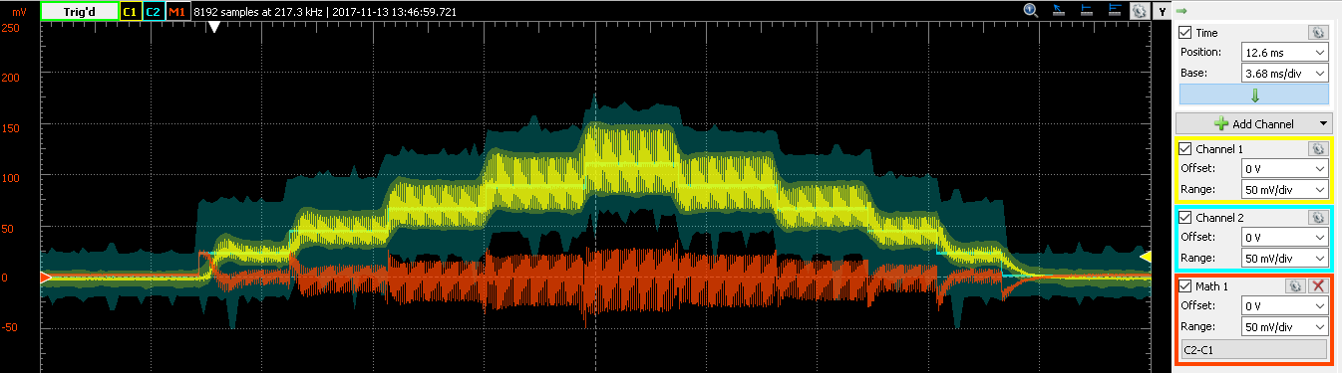



**PID Controller:**

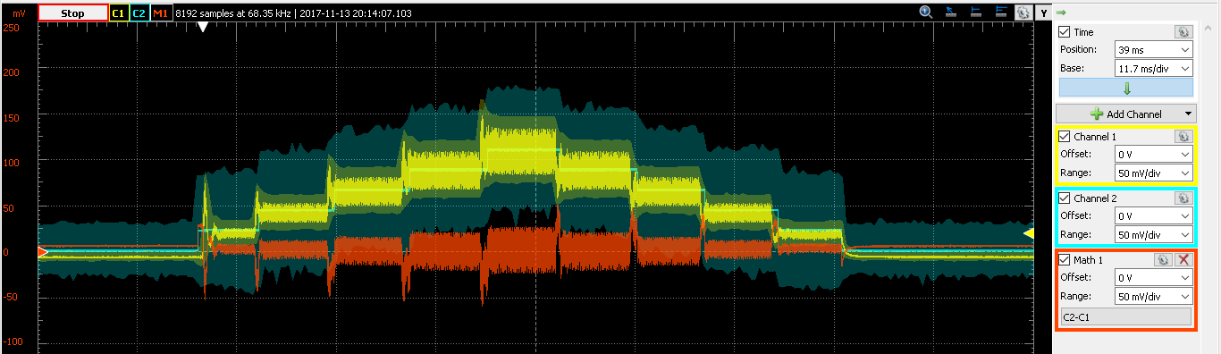



## Extra Credit: Raising Switching Frequency

## 

Table for Switching Frequency of 32Khz:

|  |  |  |  |
| --- | --- | --- | --- |
| **Controller Type** | **Control Loop Frequency (fctl)** | **CPU Utilization by Controller** | **Maximum Absolute Value of Current Error** |
| **Proportional** | 16 KHz | 46.92% | 19.2679 mA |
| **PID** | 16 KHz | 64.12% | 31.64 mA |

**PID: 40.08/62.5(us)**

**Proportional: 29.33/62.5**

**Proportional Controller:**

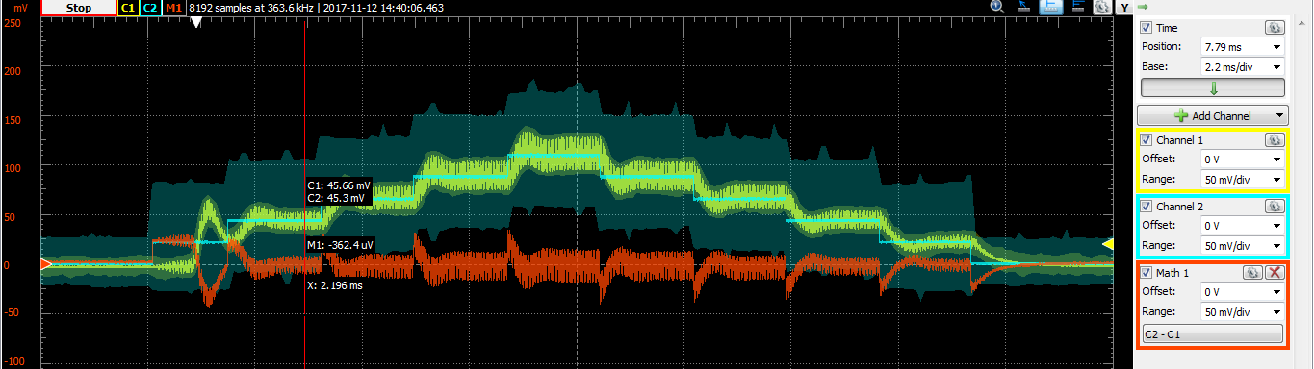



**PID Controller:**

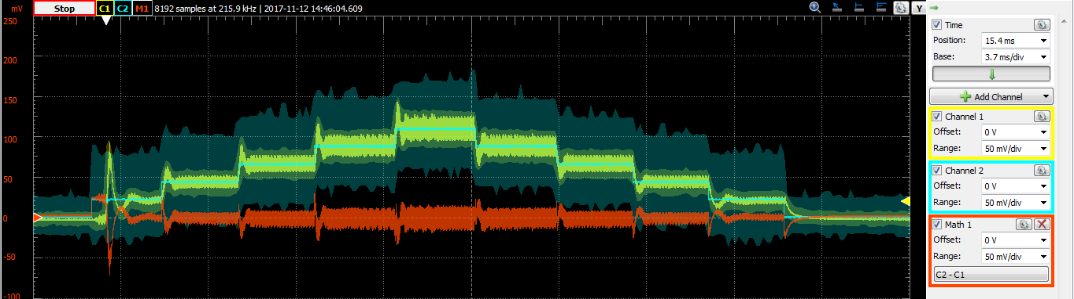



Table for varying switching frequency with Control frequency being constant at 16kHz:

|  |  |  |  |  |
| --- | --- | --- | --- | --- |
| **Switching Frequency** | **CPU Utilization** | | **Maximum Absolute Value of Current Error** | |
|  | **Proportional** | **PID** | **Proportional** | **PID** |
| 48 | 13.24% | 28.79% | 19.11mA | 35.61mA |
| 64 | 14.80% | 32.12% | 19.26mA | 33.32mA |
| 80 | 14.90% | 26.89% | 24.61mA | 36.23mA |
| 96 | 14.80% | 27.87% | 27.51mA | 71.83mA |

## Extra Credit: The Mystery of the Glowing LED

The LED glowing is seen upto switching frequency of 12KHz. Beyond that, we do not see the LED glowing between 2 current cycles. The reason for this is that the capacitor acts as a low pass filter and holds certain charge when the frequency is lower than 12K. This charge then is discharged through the LED when the inductor is charging due to the transistor being ON.

## Performance Summary Scatter Plot

The following shows the scatter plot for Bang Bang Controller when realized using different approaches:

The following shows the scatter plot for Proportional Controller when realized using different approaches:

The following shows the scatter plot for PID Controller when realized using different approaches:

The following shows the scatter plot for Proportional Controller when realized for different switching frequencies while keeping control frequency constant at 16 kHz:

The following shows the scatter plot for PID Controller when realized for different switching frequencies while keeping control frequency constant at 16 kHz:

The following shows the scatter plot for Proportional Controller when realized for different acceptable absolute current error for triggering ADC:

The following shows the scatter plot for PID Controller when realized for different acceptable absolute current error for triggering ADC: